Passion Project
Student Toolbox

Name _______________________________________________________________
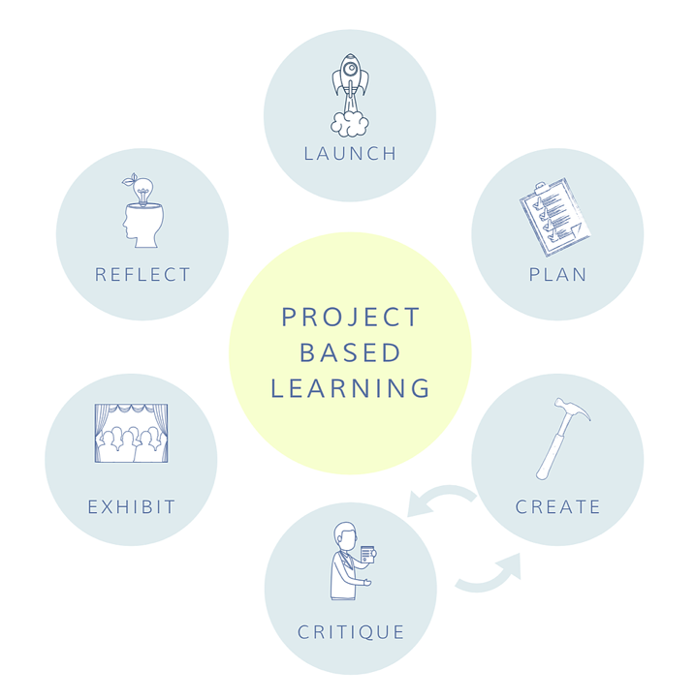

Project Overview

Welcome to Passion Project! In this project, you are going to explore something that you’re interested in or curious about! You will have (number of weeks) to complete this project. Throughout this process, you will plan your time, research, create a product, get feedback and present your final work to (audience) at the end. We will reflect together as a class about what you learned in this process when it is finished.

Calendar and Deadlines*
Monday | Tuesday | Wednesday | Thursday | Friday
 | List of possible topics and questions posted on (online learning platform) for feedback | Give feedback to classmates on their ideas  Choose topic and question | Research and PLAN | Research and PLAN
Detailed plan for project posted on (online learning platform) for feedback from teacher | Check-In with your Critical Friend online about your project. | Individual Check-In’s with teacher via (online learning platform) |  | Check-In with your Critical Friend online about your project.
 | Post an update to the class on (online learning platform) about what you’re working on (include pics!) |  |  | Check-In with your Critical Friend online about your project.
 |  | Individual Check-In’s with teacher via (online learning platform) | Prepare presentation for (audience) | Post Presentation Reflection Questions on (online learning platform)
*This is subject to change

If you need help:
If you find you’re stuck or not knowing what to do, you can always get help! Here are some places to try:

Your Critical Friend:

Name _______________________________________________
Email ________________________________________________
Phone _______________________________________________

Your Teacher:

Name _______________________________________________
Email ________________________________________________
Phone _______________________________________________

You can always ask your family members for help, too! Maybe they have some ideas that no one else has thought of.

Critical Updates
Before you start working each day, be sure you check the (online learning platform) for updates and helpful advice about your Passion Projects. There might be changes to the calendar that are important for you to consider.

At the end you will present:

- Complete Toolbox (this document)
- Product
- Any supporting products to help you describe your project (like drafts of your work)

Some helpful advice:
Trust yourself! YOU are directing your own learning in this project, which means you need to decide what to do and what is “good enough” for this work. You may get frustrated along the way, but that’s also a part of learning. Learning is messy, sometimes unclear and hard! Follow your plan and reach out to your Critical Friend or Teacher if you feel really stuck.

Ready? Set? GO!
Step 1: Brainstorm Ideas

What are things you’re interested in? Passionate about? If you could spend a whole day doing something… what would it be? Make a list of 10 things you would like to consider as a topic for this project.

- _________________________________________________________
- _________________________________________________________
- _________________________________________________________
- _________________________________________________________
- _________________________________________________________
- _________________________________________________________
- _________________________________________________________
- _________________________________________________________
- _________________________________________________________
- _________________________________________________________

Step 2: Brainstorm Questions

Choose a topic that you would like to use for this project and develop a BIG Question that will help you dig deeper. BIG Questions should be open and not have one specific answer. They can start with…
- What happens when…
- What if…
- How does…

Develop 5 BIG Questions that could be used to drive this project.

- _________________________________________________________
- _________________________________________________________
- _________________________________________________________
- _________________________________________________________
- _________________________________________________________
Post these ideas and questions to the (online learning platform) by (date).

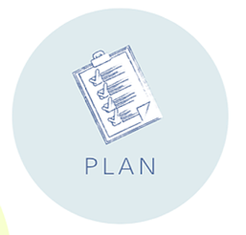

My topic for this project is ___________________________________________________

My BIG Question for this project is:
_____________________________________________________________________________

_____________________________________________________________________________

Next, you need to plan how you will complete this project by doing some research and coming up with some more ideas!

Research
Find 5 sources online to read about that will give you some background information and ideas about how to answer your BIG Question. You can use more than 5, but at least 5 must be documented in your Toolbox.

Resource #1:
Type: (website, book, blog, ??) ______________________________________
URL: _____________________________________________________________________________

_____________________________________________________________________________

Notes:

Resource #2:
Type: (website, book, blog, ??) ______________________________________
URL: _____________________________________________________________________________

_____________________________________________________________________________

Notes:

Resource #3:
Type: (website, book, blog, ??) ______________________________________
URL: _____________________________________________________________________________

_____________________________________________________________________________

Notes:

Resource #4:
Type: (website, book, blog, ??) ______________________________________
URL: _____________________________________________________________________________

_____________________________________________________________________________

Notes:

Resource #5:
Type: (website, book, blog, ??) ______________________________________
URL: _____________________________________________________________________________

_____________________________________________________________________________

Notes:

Product Ideas
A product could be anything that helps you dig deeper into your topic and BIG Question! Some ideas include: video, 3-D model, presentation, graphic novel, cookbook, essay, poem, documented experiment, song… the possibilities are endless! You should choose something that is realistic to get done in the time for this project, but also something that is really FUN and interesting for you to make!

Remember your audience is (insert audience here), so your product should also be fitting to the purpose of the project.

What products would you have fun making? __________________________________________________________________________________________________________________________________________________________

What products fit your audience?
__________________________________________________________________________________________________________________________________________________________

I am going to make _________________________________________________________

What materials are needed to make your product? How will you get them? Write down your ideas here:

What is going to be a successful product for you? How will you know if is “good enough”?

How many drafts do you plan to make of your product?

Time Planning

Using the project calendar, write in your own deadlines for your Passion Project based on the product you have chosen to make and the deadlines for the class.

You should include:
- What you plan to work on each day
- Deadlines for your drafts (depending on how many and how long you think it will take you to do)
- Final product deadline so you are prepared for presenting your work!

Monday | Tuesday | Wednesday | Thursday | Friday
 | List of possible topics and questions posted on (online learning platform) for feedback | Give feedback to classmates on their ideas  Choose topic and question | Research and PLAN | Research and PLAN
Detailed plan for project posted on (online learning platform) for feedback from teacher | Check-In with your Critical Friend online about your project. | Individual Check-In’s with teacher via (online learning platform) |  | Check-In with your Critical Friend online about your project.
 | Post an update to the class on (online learning platform) about what you’re working on (include pics!) |  |  | Check-In with your Critical Friend online about your project.
 |  | Individual Check-In’s with teacher via (online learning platform) | Prepare presentation for (audience) | Post Presentation Reflection Questions on (online learning platform)

Post your planning section and calendar to (online learning platform) for feedback from your teacher by (date).

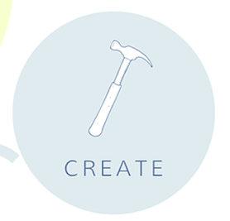

It’s time to CREATE! Using your plan, start the process of making your product. You might want to consider sketching out some ideas and using the feedback from your teacher and Critical Friend.

Don’t forget to document your process! Take photos along the way so you can reflect on the learning that’s gone into creating your product.

You need to include at least 5 photos and descriptions showing the process!

Documentation is:
- Photo of your work
- Description of what’s happening in the photo
- What you’re learning
- What worked/didn’t work

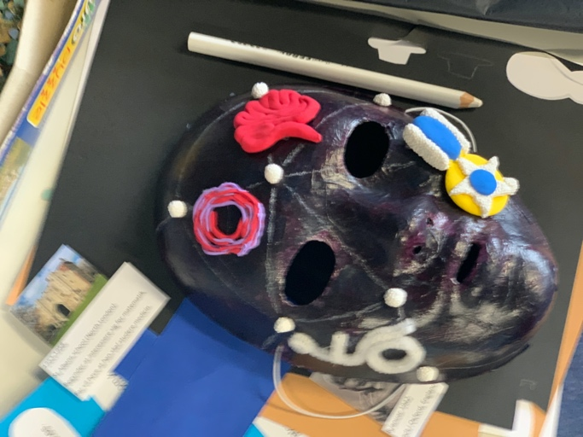
Example:

In this photo, I have painted the mask and added some of the elements that describe the person I choose to research.

I am learning how to place different elements onto the mask so it is easy to see and also balanced.

It wasn’t easy to make the brain element, I struggled with using the clay and it took 3 days to dry.

Documentation:

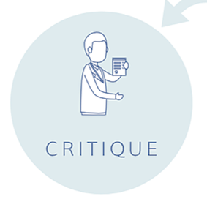

You have several Teacher and Critical Friend Check-In’s throughout this project. It is necessary to document these Check-In’s in the toolbox so you can remember the feedback you’re given and the feedback you gave!

Teacher Check-In #1
Date ______________________________________
Time ______________________________________

Feedback for me:

Teacher Check-In #2
Date ______________________________________
Time ______________________________________

Feedback for me:

Teacher Check-In #3
Date ______________________________________
Time ______________________________________

Feedback for me:

Critical Friend Check-In #1
Date ______________________________________
Time ______________________________________

Feedback for me:

Feedback for them:

Critical Friend Check-In #2
Date ______________________________________
Time ______________________________________

Feedback for me:

Feedback for them:

Additional Check-In’s
Date ______________________________________
Time ______________________________________

Feedback for me:

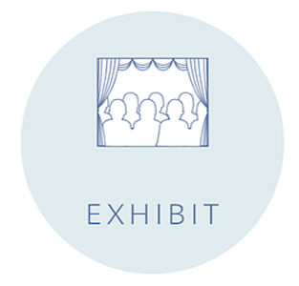

How will you present your learning and products to (audience)? How will you present both products and process? What is important to share? What did you learn?

Your presentation should last between (minutes).

Presentation Requirements:
- Complete Toolbox (this document)
- Your BIG Question (and the answer you have come up with)
- Product
- Any supporting products to help you describe your project (like drafts of your work)

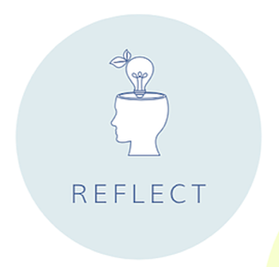

To help you prepare for your presentation and your final class reflection on your Passion Project, answer the following questions:

- What did you learn by working on this Passion Project?

- What was exciting about doing your Passion Project? What did you like?

- What was hard or frustrating about doing your Passion Project? What didn’t you like?

- If you could do your project over again, what would you do differently?

- How well did you and your Critical Friend work together? What worked? What didn’t work?

- What advice do you have for someone doing a Passion Project for the first time?

Post your answers to (online learning platform) by (date).

Congratulations! You have completed your Passion Project!

In addition to learning about your topic and trying to answer your BIG question, you have also worked with skills like: time planning, collaboration, giving feedback, taking feedback, self-directed learning, discipline and research! Hopefully you’ve also had FUN! We can’t wait to see what you’ve worked on!
